How to install Supportland-Widget?

1. **Active Supportland widget plug-in**
   1. Log in as Admin, in Dashboard, expand ‘Plugins’ and click ‘Installed plugins’
   2. Find ‘Supportland Widget’ in the plugin list and click ‘Activate’

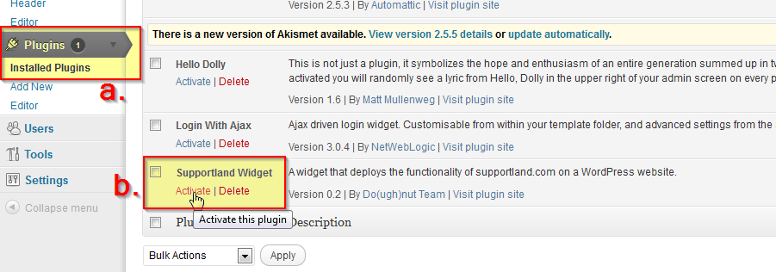

* 1. After activating the plugin, the title should be bold

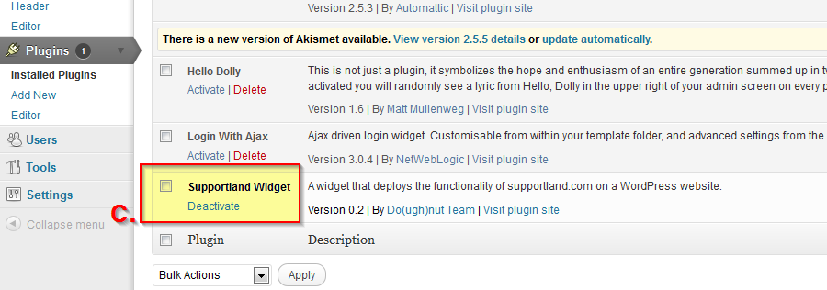

1. **Activate the widget**
   1. Go to Appearance 🡪 Widgets
   2. Locate the Supportland widget

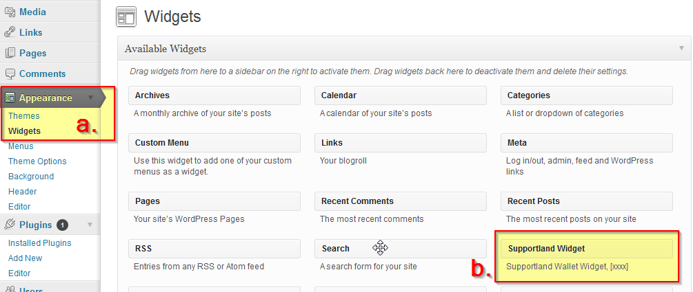

* 1. Drag it to the sidebar where you wish it to appear.

*NOTE*: depend on the theme your site is using, sidebar area options/locations might be various.

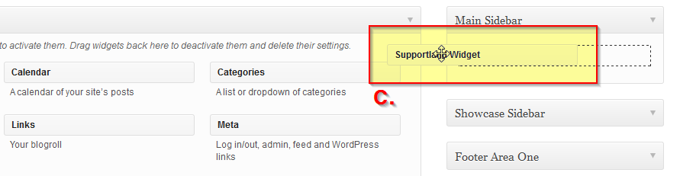

* 1. Once the widget is in place, it will look like this:

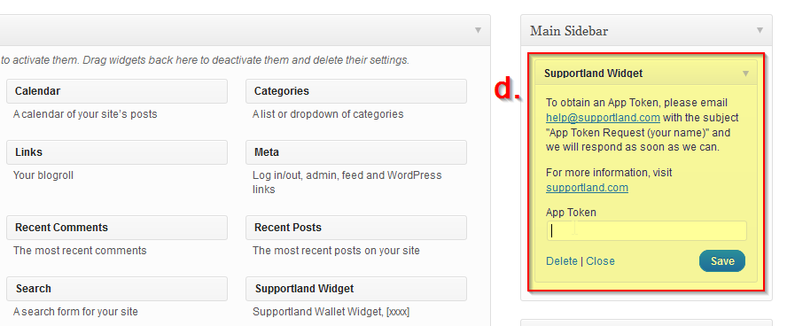

1. **Enter App token**
   1. Request an app token from Supportland site and put it to the widget.

Hit ‘Save’.

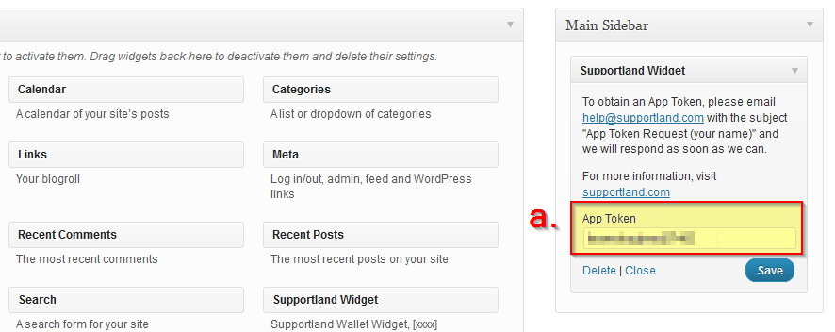

* 1. You’re good to go!

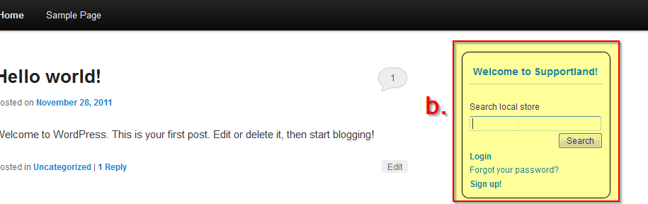

* 1. *NOTE*: if you don’t put the app token in, the widget won’t work.

